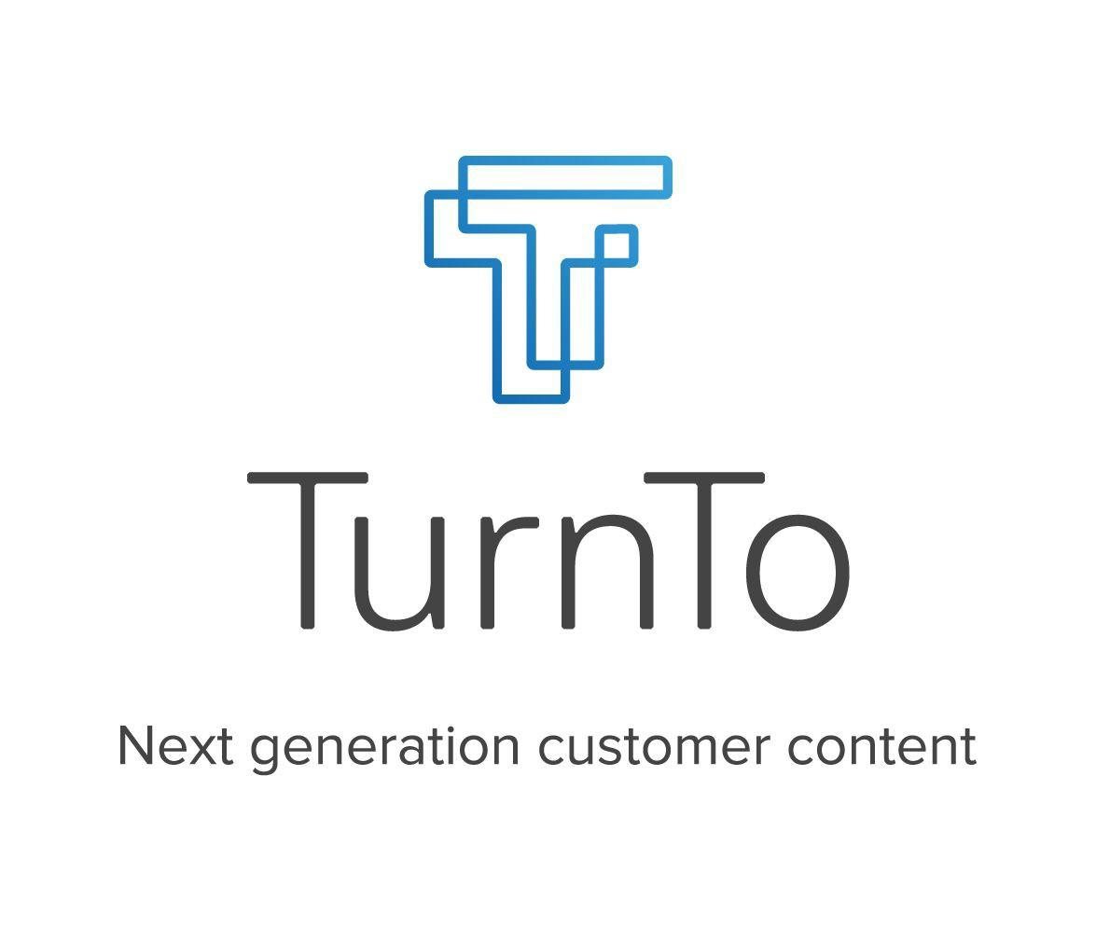

Legacy (non-SFRA) SpeedFlex™



## Table of Contents

Table of Contents 2

Setup 4

Compatibility 4

Architecture Overview 4

Localization 4

Export and Import Jobs 4

Configuration 8

Setting Up Your Site 8

Initial Setup and General Settings 8

Upload and Import Metadata/Job Schedules/Services 8

TurnTo General Settings 10

TurnTo JavaScript Feed 11

TurnTo Catalog Export Feed 11

TurnTo Historical Order Feed – Ongoing 12

TurnTo Historical Order Feed - Specific Date (Optional) 13

Multiple Locale Feed Setup 13

TurnTo SKU-to-Average Rating Feed (Optional) 15

TurnTo User Generated Content Feed (Optional) 16

Widgets 18

CGC Teaser 18

Q&A and Reviews 19

Visual Content Gallery Row 22

Visual Content Pinboard 22

Checkout Comments 22

Set up Search Settings (Optional) 25

Make User Generated Content Searchable 25

Configure Average Star Ratings as a Search Refinement (Optional) 27

Configure Average Star Ratings as a Sortable Filter 28

Installation & Code 31

Global Includes 31

TurnToConfig Object 31

Product Detail Page 32

CGC Teaser and Ratings & Reviews and Q&A Widgets 32

Visual Content Gallery Row 33

Checkout Comments Display Widget 34

Top Comment Widget 35

Category and Search Pages 36

Refinements (optional) 36

Product Tile Teaser (optional) 36

Checkout Comments Pinboard Widget (optional) 36

Checkout Comments Pinboard Teaser (optional) 36

Visual Content Pinboard 37

Other Features 38

JavaScript Order Feed 38

Checkout Comment Capture Widget 39

Testing Use Cases 41

TurnTo Site Down Scenario 41

Q&A Testing 41

Reviews Testing 42

Refinements Testing 43

Checkout Comments 44

JavaScript Order Feed Testing 45

## Setup

**IMPORTANT NOTE: This document contains integration instructions for the SGJC architecture only using either controllers or pipelines. Please refer to the SFRA document for a complete SFRA installation. Please NOTE that pipelines are not officially supported in the updated cartridge.**

**IMPORTANT NOTE: This document is for TurnTo SpeedFlex™ only, please refer to version 4.3 for older installations.**

#### Compatibility

The cartridge is designed for Salesforce Commerce Cloud API version 21.1 (Compatibility Mode: 19.10) with SiteGenesis controllers version 105.0.0.

Cartridge version 21.1.0.

#### Architecture Overview

This TurnTo LINK integration contains two cartridges, named int_turnto_core_v5 and int_turnto_sitegenesis_v5. SpeedFlex uses significantly less code on the SFCC side and most configurations are now handled within the TurnTo dashboard and rendered via the widgets JavaScript file included in the TurnTo header.

#### Localization

The cartridge supports localization for all jobs. Each job will loop through all locales declared in BM custom preference in site key for the current job scoped site. The SFCC site and product catalog supports multiple locales per instance and are mapped to multiple distinct TurnTo sites, each with their own configuration and one or more locales per site.

**IMPORTANT NOTE: Those clients using the ‘default’ locale in Salesforce will be required to modify the function “getAllowedLocales” in TurnToHelperUtil.js to use an actual locale code. The TurnTo system does not understand what the ‘default’ locale code means so please write logic to check if the locale is “default” and then replace with another locale that is accepted per TurnTo’s allowed locales.**

#### Export and Import Jobs

The int_turnto_core_v5 contains the TurnTo entry points, which contain a JS script that is used for jobs.

##### ExportHistoricalOrders

The ExportHistoricalOrders entry point exports all customer orders that have been placed in the last X days (this number is configurable via site preference). The exported data is then automatically pushed to the TurnTo system via HTTP. A temporary file, named “exportOrders.txt”, is written to a TurnTo folder within the Import/Export folder.

Example: “[your_sandbox_url]/Impex/TurnTo/[locale]/exportOrders.txt”

The file is left on the file system after the job is finished. The file is overwritten each time the export job is run.

**NOTE: Only one site can be assigned to the TurnTo Feed Upload job step**

##### ExportHistoricalOrdersByDate

The ExportHistoricalOrdersByDate entry point exports all customer orders that have been placed on X date (this date is configurable via site preference). This job is designed to be manually run in the event that order(s) from a specific date were not uploaded successfully in the past. The exported data is then automatically pushed to the TurnTo system via HTTP. A temporary file, named “exportOrder.txt”, is written to a TurnTo folder within the Import/Export folder.

Example: “[your_sandbox_url]/Impex/TurnTo/[locale]/exportOrders.txt”

The file is left on the file system after the job is finished. The file is overwritten each time the export job is run.

**NOTE: Only one site can be assigned to the TurnTo Feed Upload job step**

##### ExportCatalog

The ExportCatalog entry point exports all of the products from the catalog. The exported data is then automatically pushed to the TurnTo system. A temporary file, named “exportCatalog.txt”, is created in a TurnTo folder within the Import/Export folder.

Example: “[your_sandbox_url]/Impex/TurnTo/[locale_with_same_site_key]/exportCatalog.txt”

The file is left on the file system after the job is finished. The file is overwritten each time the export job is run.

**NOTE: Only one site can be assigned to the TurnTo Feed Upload job step**

##### ImportAverageRatings

The ImportAverageRatings entry point imports all of the average star ratings for your product SKUs from the SKU-to-Average Star Rating Feed. This data is only used for attribute refinements on pages such as search results and category landing.

All data is reset before the import.

**NOTE: You will need to contact your TurnTo support representative to enable this feed.**

**NOTE: If this job errors out and the log says invalid XML, please contact TurnTo to make sure the feed is available for your site key/auth key/domain combination.**

##### ImportUserGeneratedContent

The ImportUserGeneratedContent entry point imports all of the user-generated content (Questions, Answers, Replies, Comments, and Reviews) for all items on your site, and stores it in a searchable attribute on the product data.

All data is reset before the import.

NOTE: You will need to contact your TurnTo support representative to enable the XML version of this feed.

**IMPORTANT NOTE:** The import feeds run by attempting to process all products in the incoming file. If there are problems updating any of the product records due to locking or database availability the offending SKU will be logged to the job log file and the job will continue processing the next products. If at least one product level error occurred the job will complete but in an “ERROR” state. In this case the job logs should be examined to determine the impacted product ids. This may require the job to be manually run at a time when the resources are available.

Logger.error('Product SKU {0} failed to update due to {1}', product.ID, e.message);

Log files can be found in Business Manager here:

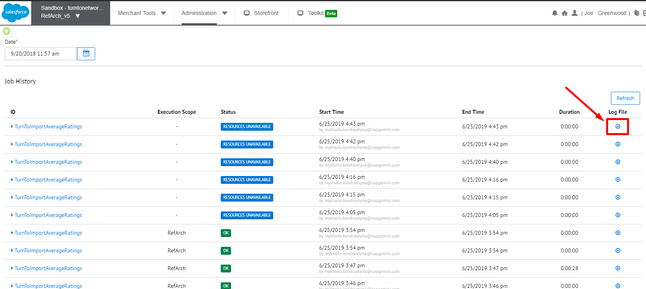

In addition, since import jobs modify catalog data if the site is sharing master products across multiple sites care should be taken:

* If all products are shared, only one site should run the import job.
* If some products are shared, each site should run the import job but should have the job schedule spread out appropriately so that two jobs are not contending to update the same product.

**NOTE: If this job errors out and the log says invalid XML, please contact TurnTo to make sure the feed is available for your site key/auth key/domain combination.**

## Configuration

### Setting Up Your Site

1. Create a TurnTo account on [www.turnto.com/register](http://www.turnto.com/register) if you don't already have one.
2. Make sure your TurnTo contact has added your site to the [turnto.com](http://turnto.com/) system.
3. Make sure your TurnTo contact has made you a TurnTo account manager of your site. Once you are a manager of your site, you will see a new navigation area on the left with your site name and links to your settings, reporting and moderation.
4. Add cartridges to site cartridge path
   1. In Business Manager, Click "Sites" in the Administration section
   2. Click the "Manage Sites" link
   3. Click the name of your site (e.g., ‘SiteGenesis’)
   4. Click the "Settings" tab
   5. Using legacy architecture, fill in the cartridge field with the following: int_turnto_sitegenesis_v5:app_storefront_controllers:app_storefront_core:int_turnto_core_v5
   6. Click Apply
5. Add cartridges to business manager cartridge path
   1. In Business Manager, Click “Sites” in the Administration section
   2. Click "Manage Sites" link
   3. Click the "Business Manager" link
   4. Using legacy architecture, fill in the cartridge field with the following as:

int_turnto_core_v5

* 1. Click Apply

### Initial Setup and General Settings

#### Upload and Import Metadata/Job Schedules/Services

1. Open the file *metadata/TurnTo_MetaData_Site_v5.zip* and un-zip it.
2. Open the jobs.xml file and modify all references to site-id="RefArch_v5" in the file, replacing them with the ID of your site.
3. Once your files are modified, zip the folder back up.
4. In Business Manager, click "Site Development" in the Administration section
5. Click "Site Import & Export" and then, under the section “Upload Archive”, select the “Local” radio button.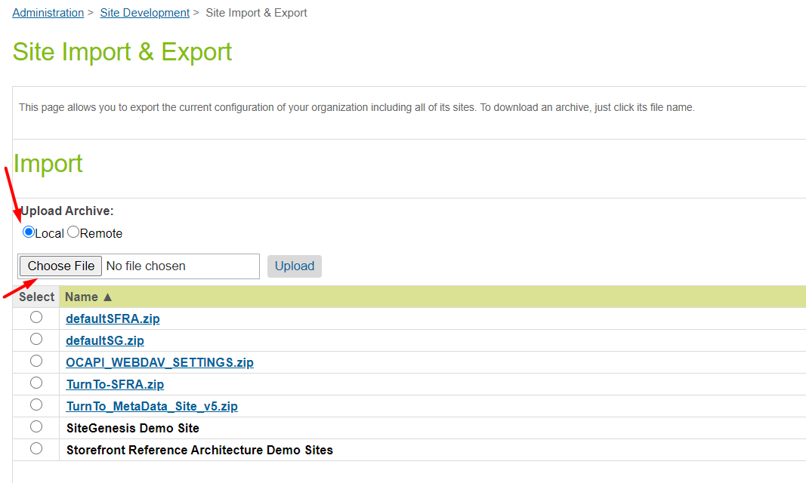
6. Click “Choose File” and choose the file located in *metadata/ TurnTo_MetaData_Site_v5.zip* and click "Upload"
7. Under the section with “Select Name”, you will see the file “
8. Select the file you just uploaded and click "Import".
9. A message will appear saying “Are you sure that you want to import the selected archive?”, Click “OK”

#### TurnTo General Settings

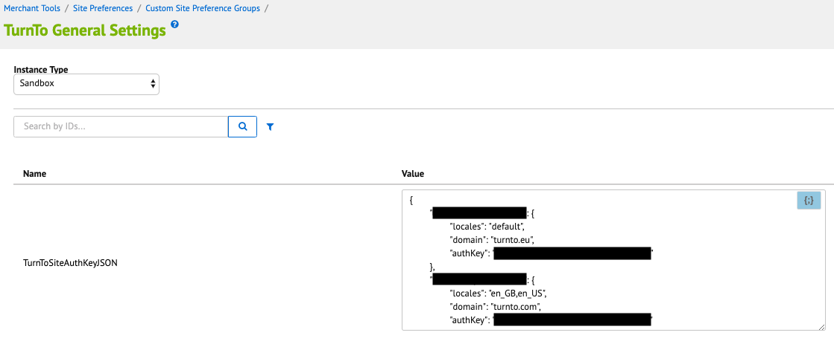

**NOTE: Notice that the auth and site keys are localized in the JSON**

1. In Business Manager, click "Custom Preferences" in the Merchant Tools section, under Site Preferences
2. Click on "TurnTo General Settings" and then fill out the following information (* means required):
   1. TurnToSiteAuthKeyJSON: the JSON uses site key(s) as the main key(s) and then requires the locale(s), domain and auth key.
      1. formatting

{

"[site_key]": {

"locales": "[locale_name(s)]",

"domain": "[domain]",

"authKey": "[auth_key]"

}

}

* + 1. sample (3 locales)

{

"12345site": {

"locales": "en_US",

"domain": "turnto.com",

"authKey": "12345auth"

},

"98765site": {

"locales": "en_GB,fr_FR",

"domain": "turnto.eu",

"authKey": "98765auth"

},

}

* 1. Use Variants – Set to ‘Yes’ to include product variants in the catalog feed and show the reviews for individual variants on the product details page. Reviews for other variants will be shown as related reviews. Default is ‘No’

1. Click Apply

#### TurnTo JavaScript Feed

Purpose: Collects real-time order data on the order confirmation page

1. In Business Manager, click "Custom Preferences" in the Merchant Tools section, under Site Preferences
2. Click on "TurnTo Feeds" and then fill out the following information:  
   JavaScript Feed (on Order Confirmation): "Yes" if you want to enable the collection of real-time order data on the order confirmation page, "No" otherwise
3. Click Apply

#### TurnTo Catalog Export Feed



Purpose: Generates a catalog feed in the TurnTo format and uploads it to [turnto.com](http://turnto.com/) via HTTP for processing

The catalog export feed is localized and may contain multiple feeds if more than one site level locale is enabled.

**NOTE: The catalog feed includes links to product images. By default, the image store is used. If you use a third party to store your images you’ll need to modify ExportCatalog.js in the int_turnto_core_v5 cartridge to point to your image store.**

1. Login to your Business Manager account
2. Click the Operations link in the Administration section
3. Click Job Schedules
4. Click "TurnToCatalogExport”
5. Configure your desired run frequency, as well as any notifications, and make sure "Enabled" is checked
6. Verify the steps in the “Step Configurator” are set to the correct site
7. Click Apply
8. Recommendations:
   1. Run this job schedule once manually, to perform the initial load of your product catalog into the TurnTo system
   2. Configure error handling for your email address for testing.

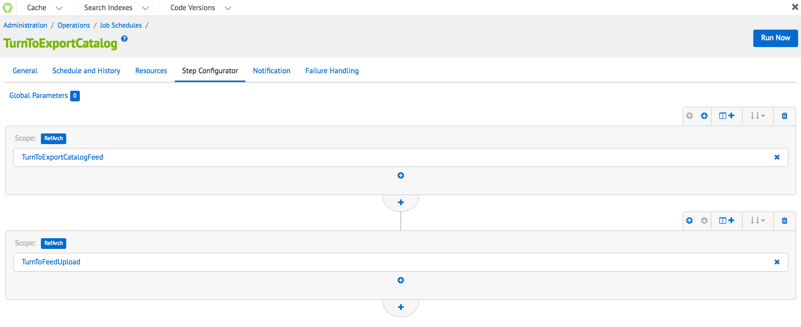

#### TurnTo Historical Order Feed – Ongoing

Purpose: Generates an order feed in the TurnTo format and uploads it to [turnto.com](http://turnto.com/) via HTTP for processing

The order export feed is localized and may contain multiple feeds if more than one site level locale is enabled.

1. Login to your Business Manager account
2. Click the Site Preferences Link in the Merchant Tools section for your site
3. Click Custom Preferences and then TurnTo Feeds
4. Update the "Historical Order Days" preference to the number of days you want to be exported (typically 2 or 3)
5. Click the Operations link in the Administration section
6. Click Job Schedules
7. Click "TurnToHistoricalOrderExportOngoing”
8. Configure your desired run frequency, as well as any notifications, and make sure "Enabled" is checked
9. Verify the steps in the “Step Configurator” are set to the correct site
10. Click Apply
11. Recommendation: Configure error handling for your email address for testing.

#### TurnTo Historical Order Feed - Specific Date (Optional)

Purpose: Generates an order feed for a specific date in the TurnTo format and uploads it to [turnto.com](http://turnto.com/) via HTTP for processing. This job is meant to be run manually, in the event that orders were skipped by the JS Feed or the Historical Feed - Ongoing

The specific date order export feed is localized and may contain multiple feeds if more than one site level locale is enabled.

1. Login to your Business Manager account
2. Click the Site Preferences link in the Merchant Tools section for your site
3. Click Custom Preferences and then TurnTo Feeds
4. Update the "Historical Order Date" preference to the specific date you want to export
5. Click the Operations link in the Administration section
6. Click Job Schedules
7. Click "TurnToHistoricalOrderExportSpecificDate"
8. Verify the steps in the “Step Configurator” are set to the correct site
9. Click "Run"
10. Recommendation: Configure error handling for your email address for testing

#### Multiple Locale Feed Setup

Sites with multiple locales can push localized feeds to TurnTo if set up in Business Manager and in TurnTo.

**REMINDER: Those clients using the ‘default’ locale in Salesforce will be required to modify the function “allowedLocales” in TurnToHelperUtil.js to use an actual locale code. The TurnTo system does not understand what the ‘default’ locale code means so please write logic to check if the locale is “default” and then replace with another locale that is accepted per TurnTo’s allowed locales.**

##### Download (for Reviews and UGC jobs)

1. Contact your TurnTo Customer Success Manager to enable multiple locales for your TurnTo setup
2. They will provide you with a set of Site and Auth Keys
3. In Business Manager, click "Custom Preferences" in the Merchant Tools section, under Site Preferences
4. In "TurnTo General Settings" add the provided auth, domain, locale, and site key information in the TurnToSiteAuthKeyJSON field:

{

"siteKeyA": {

"locales": "en_US,en_CA",

"domain": "turnto.com",

"authKey": "authKey"

},

"siteKeyB": {

"locales": "en_GB,fr_FR",

"domain": "turnto.eu",

"authKey": "authKey"

}

}



Each download feed URL will contain the unique auth and site keys to distinguish locales.

Download Feed Example (for Reviews and UGC): <http://www.turnto.com/static/export/YOURSITEKEY/YOURAUTHKEY/turnto-ugc.xml>

##### Upload (for Catalog and Order Export jobs)

**NOTE: The following steps are the same as the previous Download section.**

1. Contact your TurnTo Customer Success Manager to enable multiple locales for your TurnTo setup
2. They will provide you with a set of Site and Auth Keys
3. In Business Manager, click "Custom Preferences" in the Merchant Tools section, under Site Preferences
4. In "TurnTo General Settings" add the provided auth, domain, locale, and site key information in the TurnToSiteAuthKeyJSON field:

{

"siteKeyA": {

"locales": "en_US,en_CA",

"domain": "turnto.com",

"authKey": "authKey"

},

"siteKeyB": {

"locales": "en_GB,fr_FR",

"domain": "turnto.eu",

"authKey": "authKey"

}

}

Upload Feed Example (for Catalog and Orders exports): <http://www.turnto.com/feedUpload/postfile>

The URL is not unique per locale, instead the content request body will contain multiple HTTP request parts to distinguish the locale using both site and auth keys.

Content HTTP Request parts

1. File -> locale specific file to upload
2. SiteKey -> locale specific site key
3. AuthKey -> locale specific auth key
4. Feed Style -> always the following string “tab-style.1”

#### TurnTo SKU-to-Average Rating Feed (Optional)

Purpose: Downloads and imports the nightly sku-to-average-rating feed for use in the attribute refinements on pages such as search results and category landing

**NOTE: In order to use this job, the steps in “Custom Job Components” must be completed.**

**NOTE: If your site has multiple locales, the feeds can be localized if setup in Business manager.**

1. Contact your TurnTo Custom Success Manager to enable the Sku Average Rating Feed for your account.
2. After the nightly feed is generated, verify that you can access the feed via a browser at: <http://www.turnto.com/static/export/YOURSITEKEYHERE/YOURAUTHKEYHERE/turnto-skuaveragerating.xml>
3. Login to your Business Manager account



1. Click “Jobs” link under Operations in the Administration section
2. Click "TurnToImportAverageRatings", and then click “Schedule and History”
3. Configure your desired run frequency, as well as any notifications, and make sure "Enabled" is checked.
4. Verify the steps in the “Step Configurator” are set to the correct site
5. Click Apply
6. After the job has successfully run, products present in the feed will have the following custom attributes populated on the Product record:
   1. turntoAverageRating
   2. turntoReviewCount
   3. turntoRelatedReviewCount
   4. turntoCommentCount
7. Recommendation: Configure error handling for your email address for testing.

#### TurnTo User Generated Content Feed (Optional)

Purpose: Downloads and imports the Customer Generated Content XML feed for all products, so that the TurnTo content can be searchable on the storefront or used for SEO.

**NOTE: In order to use this job, the steps in “Custom Job Components” must be completed.**

**NOTE: If your site has multiple locales, the feeds can be localized if setup in Business manager.**

1. Contact your TurnTo support representative to enable the XML version of the sitewide Customer Generated Content Feed.
2. After the nightly feed is generated, verify that you can access the feed via a browser at: <http://www.turnto.com/static/export/YOURSITEKEYHERE/YOURAUTHKEYHERE/turnto-ugc.xml>
3. Login to your Business Manager account
4. Click “Jobs” link under Operations in the Administration section
5. Click " TurnToImportUserGeneratedContent ", and then click “Schedule and History”
6. Configure your desired run frequency, as well as any notifications, and make sure "Enabled" is checked.
7. Verify the steps in the “Step Configurator” are set to the correct site
8. Click Apply
9. After the job has successfully run, products present in the feed will have the following custom attributes populated on the Product record:
   1. turntoUserGeneratedContent
10. Recommendation: Configure error handling for your email address for testing.

## Widgets

**IMPORTANT NOTE: SpeedFlex widgets are enabled via the TurnTo dashboard and sent via the widgets JS file. There is however some coding setup that is required for certain features (primarily div element placement).**

**NOTE: Except for the teasers all widgets below use the turnto.js file to obtain and render the HTML and content for features.**

#### CGC Teaser

The teaser is a condensed version of the reviews summary and list content and contains calls to action that bring the shopper to review and/or Q&A content.

**NOTE:**

* Teasers are the only content that do not use the turnto.js code, the HTML and logic is contained within the teasers.js file
* Widget can be enabled/disabled via custom preference in SFCC Business Manager
* Teasers require a minimum of 4 reviews to show the read comments section. This can be modified in the teasers.js file.

You can include the following information in your CGC Teaser implementation:

* Ratings & Reviews
  + The average Star Rating for this product
  + How many reviews have been published
* Questions & Answers
  + How many questions have been published for this product
  + How many answered questions have been published for this product
  + How many answers have been published for this product
* Checkout Comments
  + How many Checkout Comments have been published

##### Implementation Example

This section provides example output based on simple JavaScript, CSS, and HTML markup.

Here’s example output on product display pages with both Reviews and Checkout Comments: 

On pages with Checkout Comments but no Reviews:



On pages with Reviews but no Comments (or you choose to exclude Comments from the Teaser): 

Or on pages with no Reviews or Comments (or you choose to exclude Comments from the Teaser):



##### Teaser Stars

The teaser stars are configured by default to use SVGs, as you can see in the starsvgs.isml template.

If you prefer to use images other than SVGs, you’ll need to modify the image reference in the generateTeaserStar and generateTeaserStars functions below.

Documentation -> <https://turnto.zendesk.com/hc/en-us/articles/360023049991-Creating-a-CGC-Teaser>

#### Q&A and Reviews

Widgets can be enabled/disabled via custom preference in SFCC Business Manager

##### Review Summary Widget

By default the Review Summary widget is added to the widgets template along with the Review List widget.

The Review Summary widget succinctly summarizes your review data on the PDP, showing the following elements:

* Overall Rating count
* Average Overall Rating
* Average Overall Rating star display
* Write a Review button
* Rating distribution display - click to filter the Review List widget by selected star rating
* Summaries of any custom review dimension data (e.g., Value, Fit, etc.)

No Rating Display - If there are no ratings to summarize, the displays changes to a one-column call-to-action: 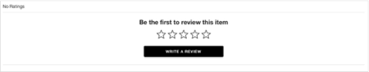

All text within the Review Summary widget can be customized. Contact your TurnTo account team to learn more

##### Review List Widget

By default the Review List widget displays with the Review Summary widget in the widgets template. Both can be enabled or disabled in the SFCC Business Manager.

The Review List widget displays a list of shopper Ratings & Reviews for a product.

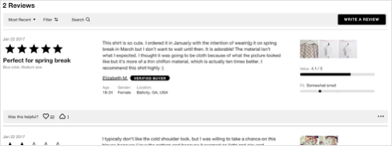

The Review List widget shows the following elements:

* Total review count (‘# Reviews’)
* Sort / Filter bar - only displays if there are 3 or more reviews for a SKU
  + Sort - ability to sort reviews by most helpful, most recent, oldest, highest, and lowest rated
  + Filter Reviews - ability to filter reviews by one or more star ratings
  + Write a Review button - launches Review Submission form
* Review List Items - all published shopper Ratings & Reviews for this product
* Pagination

Documentation -> <https://turnto.zendesk.com/hc/en-us/articles/360022609231-Review-Display-Widgets-5-0>

##### Q&A Instant Answers Widget

By default, the Q&A Summary widget is added to the widgets template along with the Q&A List widget.

TurnTo’s Community Q&A product includes the Instant Answers widget and the Q&A List widget.

Documentation -> <https://turnto.zendesk.com/hc/en-us/articles/360025543232-Community-Q-A-Widgets-5-0>

##### Q&A List Widget

By default the Q&A List widget displays with the Q&A Summary widget in the widgets template. Both can be enabled or disabled in the SFCC Business Manager.

The Q&A List widget shows the following elements:

* Ask a question
* Search for a question
* Question(s) (if available)
* Answer(s) (if available)
* Reply(s) (if available)

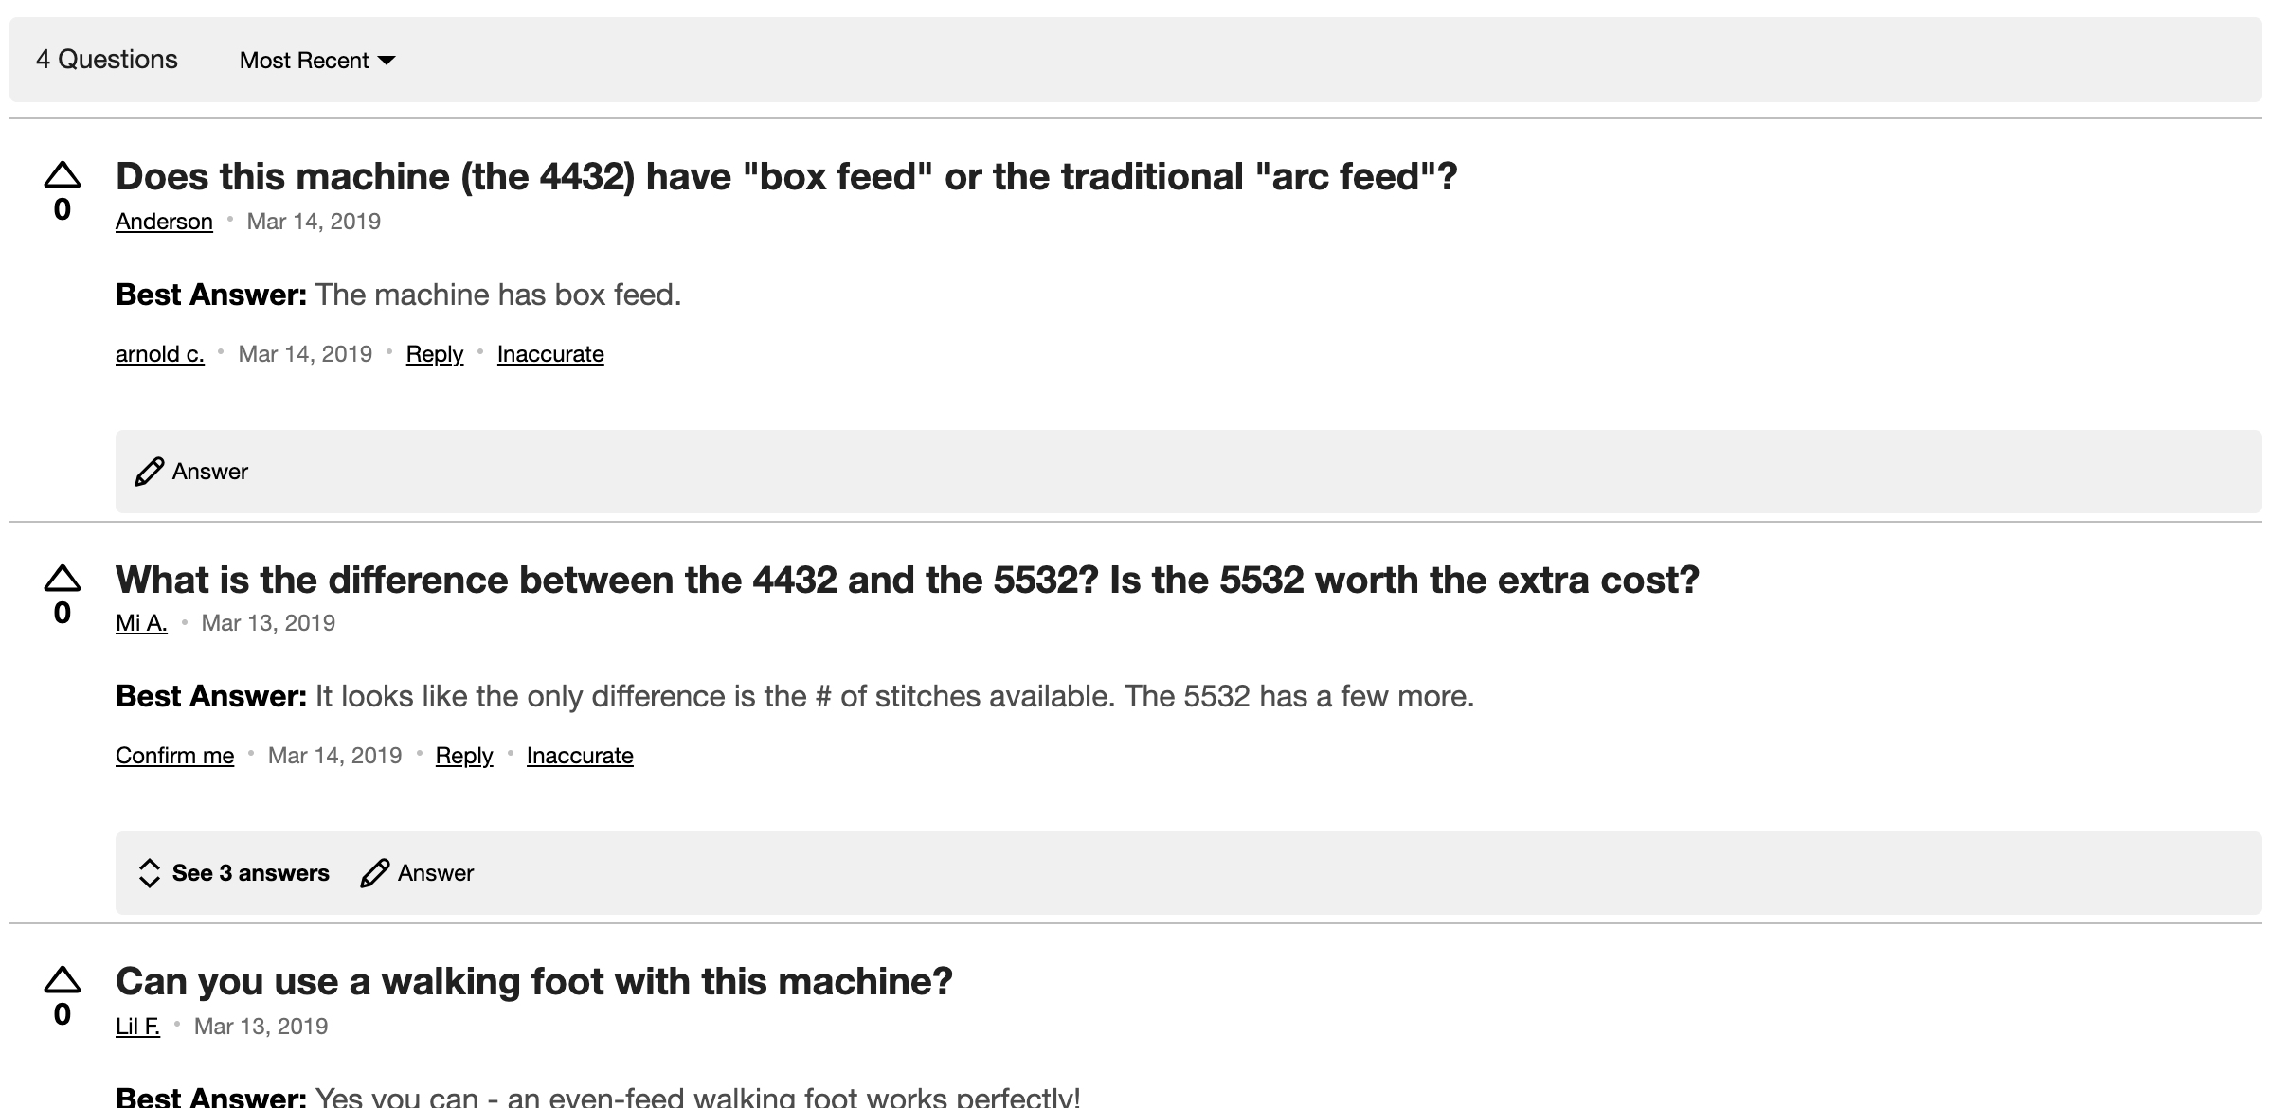

#### Visual Content Gallery Row

The Visual Content Gallery Row widget showcases end-user submitted visual content (photos and videos) for one or more SKUs or product categories. It is intended for installation primarily on the product detail page, typically between the site's product image and the product detail tabs. The widget could also be used on a category page or other landing page.

Documentation -> <https://turnto.zendesk.com/hc/en-us/articles/360028878471-Visual-Content-Gallery-Row-Widget>

#### Visual Content Pinboard

TurnTo's Visual Content Pinboard showcases customer-submitted images and videos in a responsive browsing experience. The pinboard shows submitted visual content along with a caption, username, and datestamp (optional). Clicking on an image opens the visual content modal, which displays an enlarged version of the media, the caption, user name, datestamp, product name, and a "Shop Now" button.

Documentation -> <https://turnto.zendesk.com/hc/en-us/articles/360030227731-Visual-Content-Pinboard>

#### Checkout Comments

Includes the following features:

* Checkout Comments Display PDP Widget
* Checkout Comments Top Comment Widget
* Checkout Comments Pinboard
* Checkout Comments Pinboard Teaser
* Checkout Comments Capture Widget

**NOTE**: All Checkout Comment features except the Comment Capture widget can be enabled or disabled as you wish in the SFCC Business Manager. The Comment Capture widget can be disabled by contacting your TurnTo Customer Success Manager.

##### Checkout Comments Display PDP Widget

This feature can be enabled or disabled by customer preference in SFCC Business Manager.

Some clients choose to integrate shopper Checkout Comments within the Q&A List widget, such that ‘Why did you choose this?’ is the first question asked, and the comments collected are displayed as the answer:

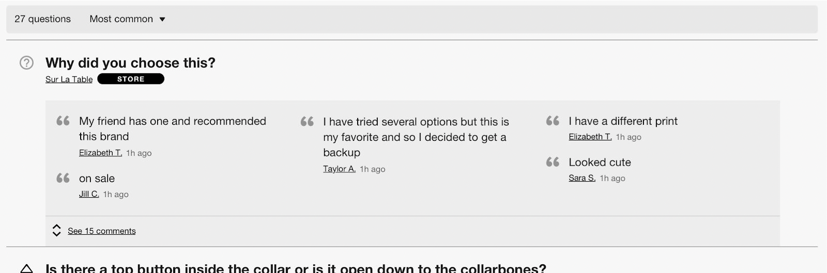

The Comments Display widget offers a popular alternative, displaying comments for a given SKU or product category in a stand-alone widget that can be placed prominently on the product detail page.

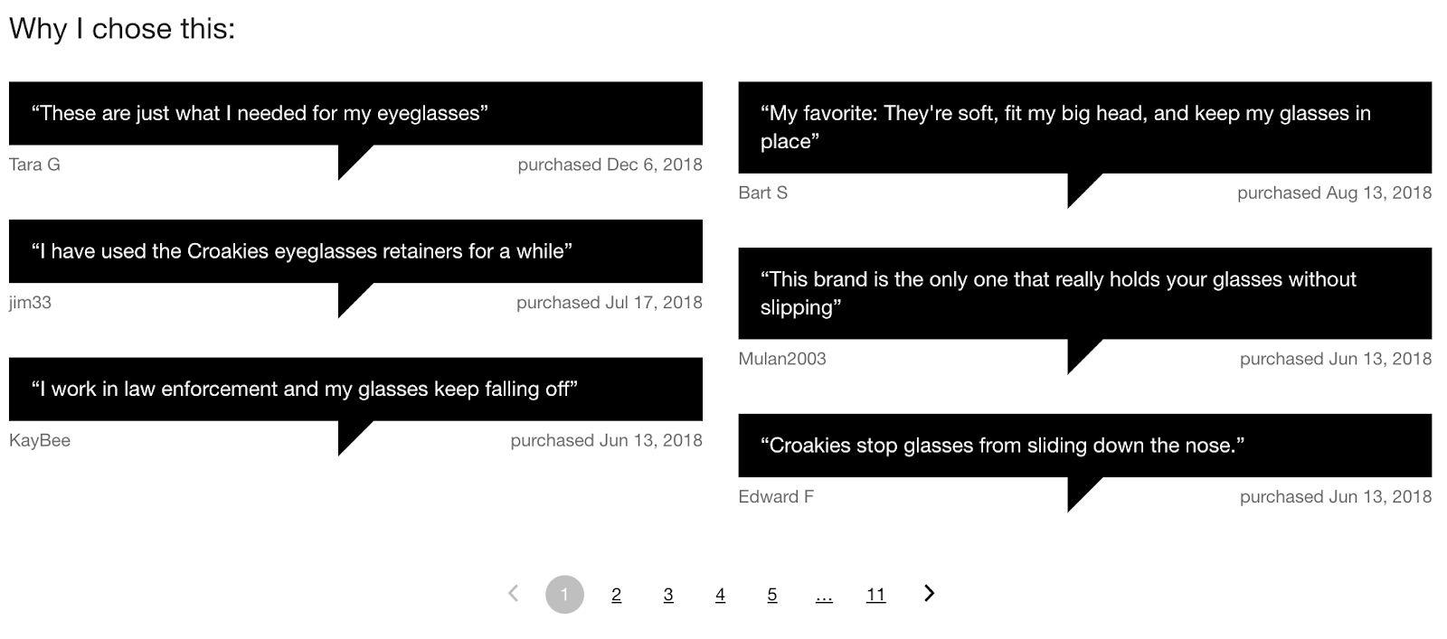

Documentation -> <https://turnto.zendesk.com/hc/en-us/articles/360022605211-Comments-Display-Widget-5-0>

##### Top Comment Widget

This feature can be enabled or disabled by customer preference in SFCC Business Manager.

The Checkout Comments Top Comment widget returns a single Checkout Comment for each SKU provided. Comments are chosen in order of recency, but the widget can easily be filtered to display only comments with a specific TurnTo Content Tag. This flexible widget promotes customer testimonials on product detail, product listing, and / or custom landing pages.

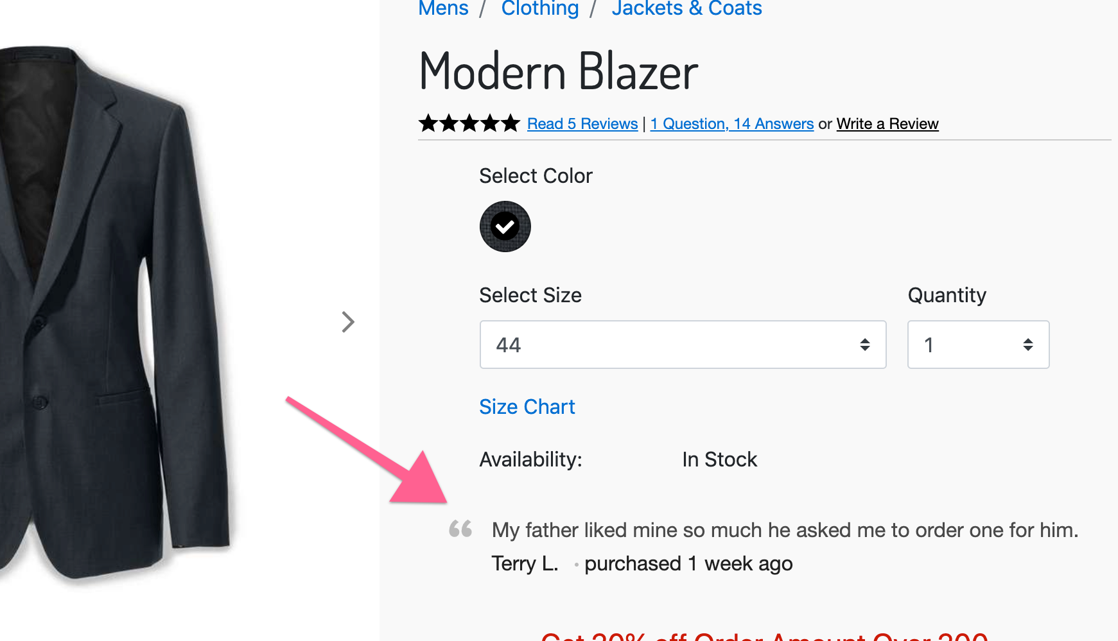

Documentation -> https://turnto.zendesk.com/hc/en-us/articles/360022605471-Top-Comment-Widget-5-0

##### Checkout Comments Pinboard

This feature can be enabled or disabled by customer preference in SFCC Business Manager.

The Checkout Comments Pinboard displays published Checkout Comments for one or more products in a streaming layout organized by product. Comments display underneath a product photo and title that link to your product detail page.

<https://turnto.zendesk.com/hc/en-us/articles/360022603391-Comments-Pinboard-5-0>

Documentation -> <https://turnto.zendesk.com/hc/en-us/articles/360022603391-Comments-Pinboard-5-0>

##### Checkout Comments Pinboard Teaser

This feature can be enabled or disabled by customer preference in SFCC Business Manager.

TurnTo's Checkout Comments Pinboard Teaser widget offers a content-rich user experience on category or product listing pages. It showcases the latest Checkout Comments for one or more active SKU(s), brands, content tags, and/or product category(ies).

Documentation -> <https://turnto.zendesk.com/hc/en-us/articles/360023587572-Comments-Pinboard-Teaser-5-0>

##### Checkout Comments Capture Widget

This feature can be enabled or disabled by customer preference in SFCC Business Manager.

The Comment Capture widget asks shoppers 'Why did you choose this product?' on the order confirmation page, allowing you to gather immediate positive product sentiment much sooner than traditional Ratings & Reviews.

Documentation -> <https://turnto.zendesk.com/hc/en-us/articles/360022365432-Comment-Capture-5-0>

**NOTE: The comment capture widget will not display if an order number is passed that matches an order number already existing in the TurnTo system. If you are integrating an existing TurnTo account with a new installation of SFCC please ensure that you’ve set the Order Number Sequence (in Business Manager… Sequence Numbers) so that new incoming order numbers are not identical to order numbers that already exist for your site in TurnTo.**

### Set up Search Settings (Optional)

#### 

#### Make User Generated Content Searchable

Purpose: Making shopper-submitted content searchable helps other shoppers refine their product search and can be helpful for SEO.

**NOTE: The data needed for this functionality comes from the User Generated Content Feed.**

1. Login to your Business Manager account
2. Click the Search link under Merchant Tools for your site
3. Click Searchable Attributes
4. Click "New" and add attribute "custom.turntoUserGeneratedContent" to the list, then give it an appropriate Boost Factor
5. Click Apply

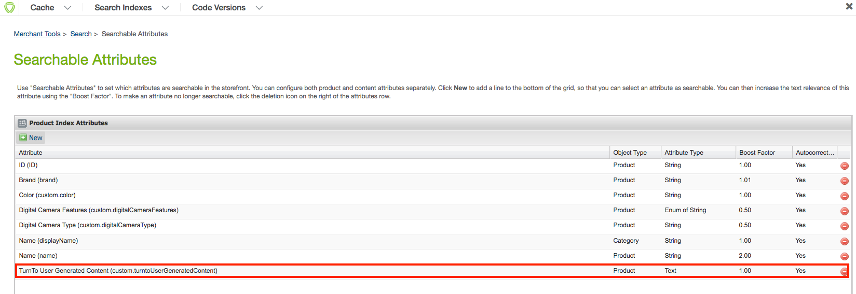

1. Under the Business Manager header, click Search Indexes
2. Check the box for "Product Index" and click Rebuild
3. Now, when you search for specific text that exists in a review, comment, or question, the matching products will show up in the search results. See the following example where the word “fantastic” is in the UGC attribute and the product shows up in the search:

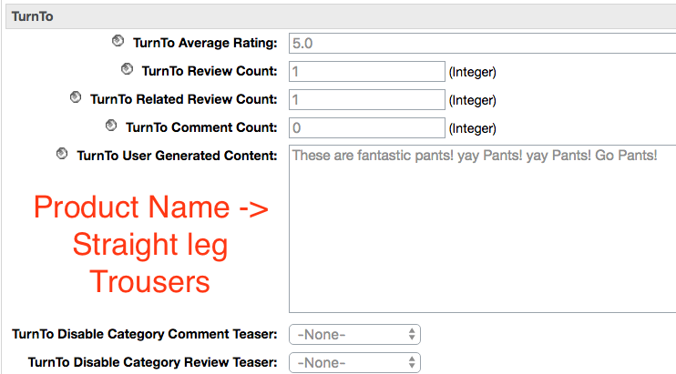

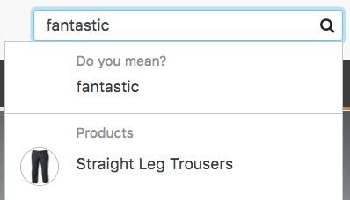

#### Configure Average Star Ratings as a Search Refinement (Optional)

**NOTE: The data needed for this functionality comes from the SKU-to-Average-Rating Feed which must be enabled and run in Business Manager.**

1. Login to your Business Manager
2. Click the “Products and Catalogs” link under Merchant Tools for your site
3. Click Catalogs
4. Click the storefront catalog of your site, and then click "Edit" on the top right
5. Click the tab for Search Refinement Definitions, and click "New"

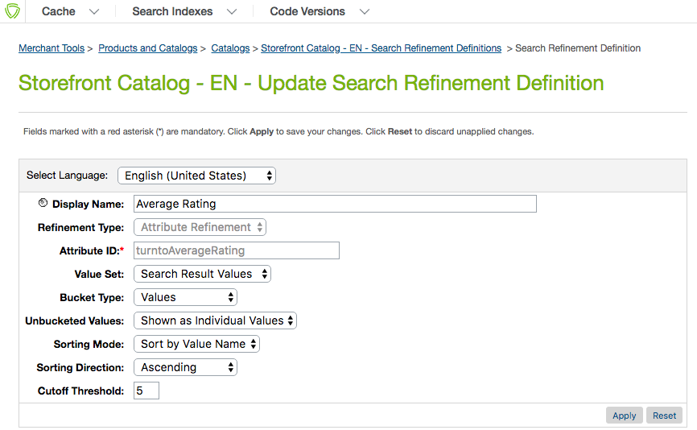

1. Update the following settings:
   1. Display Name: Average Rating
   2. Refinement Type: Attribute Refinement
   3. Attribute ID: turntoAverageRating
   4. Value Set: Search Result Values
   5. Bucket Type: Values
   6. Unbucketed Values: Show as Individual Values
   7. Sorting Mode: Sort by Bucket Position
   8. Sorting Direction: Ascending
   9. Cutoff Threshold: 5
2. Click Apply
3. Under Attribute Bucket Refinements, add the following buckets as shown in the image below:

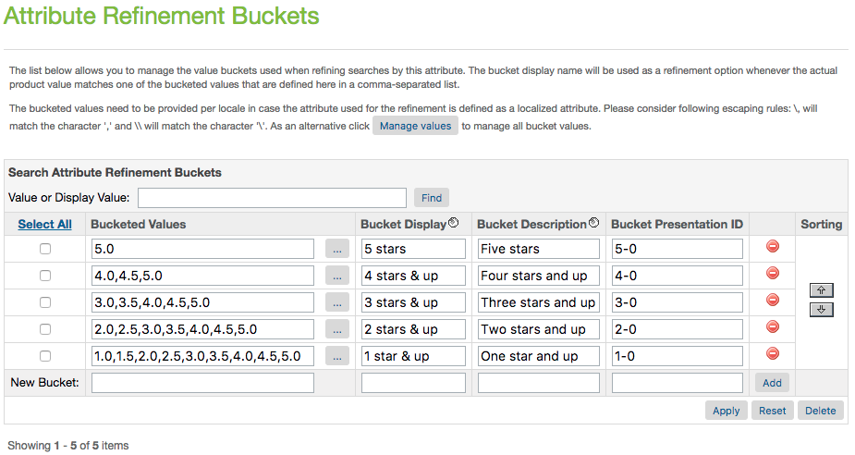

1. Click Apply
2. Under the Business Manager header, click ‘Search Indexes’
3. Check the box for "Product Index" and click Rebuild
4. You should now see the refinement for Average Rating on your category and search pages, as seen below:

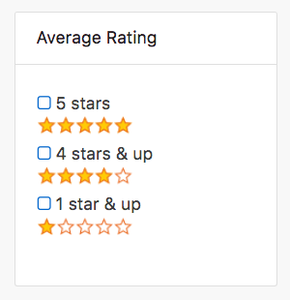

#### Configure Average Star Ratings as a Sortable Filter

**NOTE: The data needed for this functionality also comes from the SKU-to-Average-Rating Feed**

1. Login to your Business Manager account
2. Click the “Search” link under Merchant Tools for your site
3. Click Sorting Rules
4. Click "New" to add a new sorting rule, with the following settings:
   1. ID: turnto-ratings
   2. Description: Sorts by TurnTo Average Rating
5. With "turnto-ratings" now selected, click Add to add attributes.
6. Select the attribute "TurnTo Average Rating (product.custom.turntoAverageRating), sort direction by "Descending", text relevancy "N/A", and click Apply.

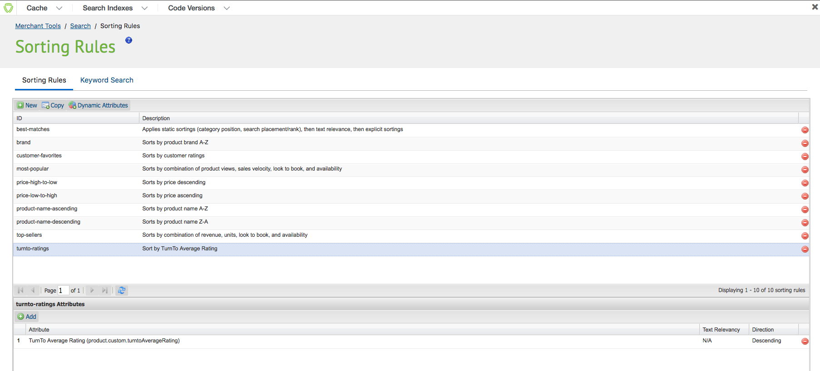

1. Go back to Search, under the Merchant Tools for your site
2. Click ‘Storefront Sorting Options’
3. Add a new sorting option, with the following settings:
   1. ID: ratings
   2. Sorting Rule: turnto-ratings



* 1. Display Name: Average Rating

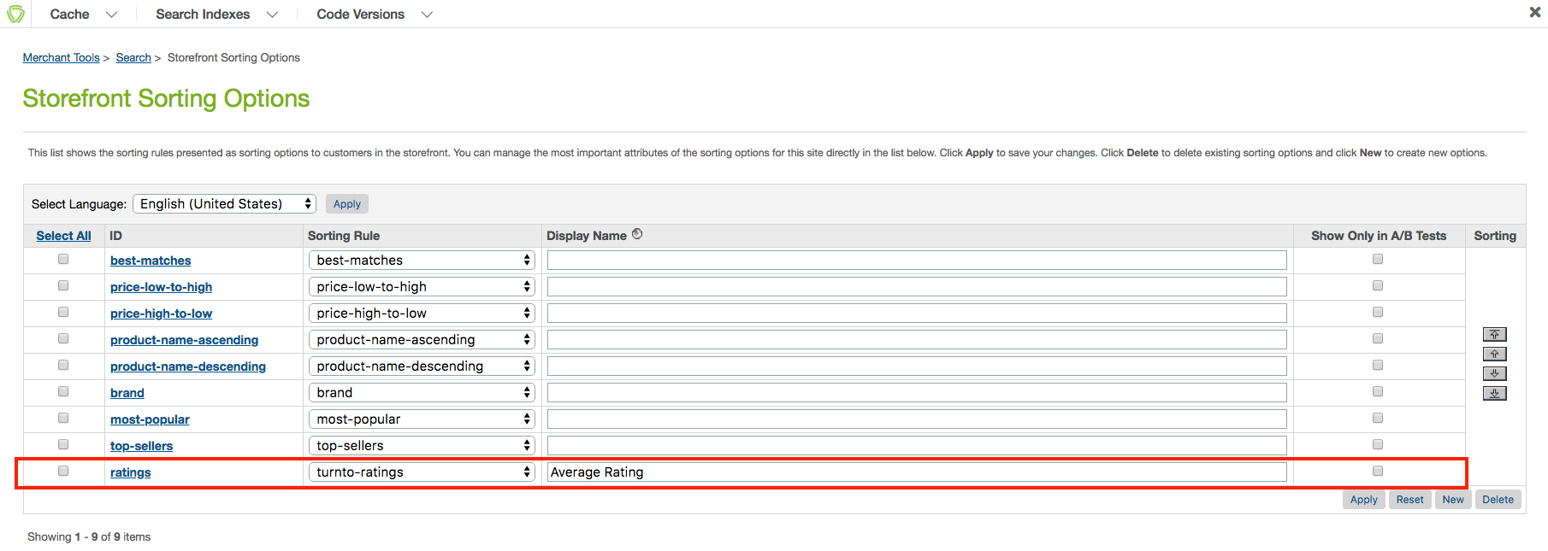

1. Click Apply
2. Under the Business Manager header, click Search Indexes
3. Check the box for "Product Index" and click Rebuild
4. You should now see the refinement for Average Rating on your category and search pages

## Installation & Code

No custom code is required, as the TurnTo cartridge overlays with the Site Genesis cartridge and implements the necessary templates and controller enhancements for all functionality.

Clients who wish to customize these templates can refer to the following listing of the custom templates and descriptions. Any and all of these templates may be copied from the cartridge into storefront overlay cartridges or alternatively used as a reference for customization.

* checkout/confirmation/confirmation.isml
* components/header/htmlhead.isml
* components/footer/footer_UI.isml
* content/home/homepage.isml
* content/contentpage.isml
* product/components/reviews.isml
* product/components/reviewsmini.isml
* product/productcontent.isml
* product/producttopcontent.isml
* rendering/category/categoryproducthits.isml
* search/components/productsearchrefinebar.isml

### Global Includes

#### TurnToConfig Object

Every page will require a TurnToConfig object, which must have a locale, page ID, and TurnToCmd command. The object may or may not have additional attributes.

**NOTE: The TurnToConfig objects are located on the “htmlheadincludejs.isml” template and are pre-configured for pages such as PDP, checkout, confirmation and search results.**

Base TurnToConfig object Example (Not including advanced configurations)

var turnToConfig = {

locale: “en_US”,

pageId: “pdp-page”

}

window.TurnToCmd=window.TurnToCmd||function(){(TurnToCmd.q=TurnToCmd.q||[]).push(arguments)};

<script src="https://widgets.turnto.com/v5/widgets/${siteKey}/js/turnto.js" async></script>

### Product Detail Page

#### CGC Teaser and Ratings & Reviews and Q&A Widgets

The teasers logic relies on a separate JavaScript file, teasers.js, which needs to be placed on your site.

**NOTE: The teasers.js is placed in the footer_UI template out of the box.**

**NOTE: Teasers require a minimum of 4 reviews to show the read comments section. This can be modified in the teasers.js file.**

The following code needs to be placed on the page for the widget JS to properly render the data:

<div id="tt-teaser" class="TTteaser"></div>

The PDP reviews summary and list rely on the following two div elements to be placed on the page for the widget JS to properly render the data:

<div id=”tt-reviews-summary”></div>

<div id=”tt-reviews-list”></div>

**Notes:**

1. The PDP page will contain the above two DIVs by default but will only display data if it exists for the current SKU.
2. If a user selects a variant SKU, the TurnTo configuration object auto-refreshes via the following JavaScript function:

TurnToCmd{‘set’, {‘sku’:’newsku’});

The Q&A summary and list rely on the following two div elements to be placed on the page for the widget JS to properly render the data:

<div id=”tt-instant-answers-widget”></div>

<div id=”tt-qa-list”></div>

**If you want to place the review content underneath a tab, you will need to do the following:**

Add a click event listener to the link. In this example, it assumes there is a function on the page that can be called to expose a tab called ‘showTab’. Change this to whatever function available on the page that accomplishes this. This code should be added to the end of the ‘populateTeaser’ function:

document.querySelector(‘.TTteaser__read-reviews’).addEventListener(‘click’, function(e) { showTab(‘reviews’); }

Documentation

* <https://turnto.zendesk.com/hc/en-us/articles/360023049991-Creating-a-CGC-Teaser>
* <https://turnto.zendesk.com/hc/en-us/articles/360022609231-Review-Display-Widgets-5-0>
* <https://turnto.zendesk.com/hc/en-us/articles/360025543232-Community-Q-A-Widgets-5-0>

#### Visual Content Gallery Row

The VC Gallery Row relies on the following div element to be placed on the page for the widget JS to properly render the data:

<div id="tt-gallery-row"></div>

Widget Refresh Function

To use the Visual Content Gallery Row widget on a page that switches product SKUs dynamically, use the built-in set function. It can be called with any SKU in the following manner:

TurnToCmd(‘gallery.set’, {skus: [sku1’,’sku2’], tags: [‘tag1’,’tag2’]})

After calling this function, the widget is updated with contents that apply to the provided SKUs.

To customize the gallery row widget, add your configurations in the gallery property within the turnToConfig object. Here is an example:

<script type="text/javascript">  
 var turnToConfig = {  
 ...  
 gallery: {   
 skus: ['sku1','sku2','sku3'],  
 tags: ['tag1','tag2','tag3'],  
 onFinish: function(){}  
 }  
 ...  
 };  
</script>

Documentation -> <https://turnto.zendesk.com/hc/en-us/articles/360028878471-Visual-Content-Gallery-Row-Widget>

#### Checkout Comments Display Widget

The Comments Display widget requires modification to the turnToConfig object for the page(s) you wish for the widget to be displayed on.

The following shows an example of the chatter attribute of the turnToConfig object:

<script>

var turnToConfig = {

sku: “YOUR PRODUCT SKU GOES HERE”,

locale: “en_US”,

pageId: “pdp-page”,

chatter: {

//onFinish: function() {}

}

}

</script>

The onFinish attribute is an optional property within turnToConfig that can be used to trigger an event record in your analytics package after the widget has finished loading.

The widget div, as follows, is placed in the widgets template

<div id=”tt-chatter-widget”></div>

##### Important Notes:

* The CC Display widget does *not* support multiple SKUs; only one product or category SKU is accepted
* If the SKU passed is a VPC parent or child then the widget will pull in comments for all sibling SKUs automatically. There is no configuration option to turn this feature on or off.
* The CC display widget requires a minimum of 4 comments in order for the widget to appear
* The CC Display widget is not currently filterable by content tag

Documentation -> <https://turnto.zendesk.com/hc/en-us/articles/360022605211-Comments-Display-Widget-5-0>

#### Top Comment Widget

The top comment widget requires modification to the turnToConfig object for the page(s) you wish for the widget to be displayed on.

The following sample shows the top comments attribute of the turnToConfig object:

<script>

var turnToConfig = {

locale: “en_US”,

pageId: “pdp-page”,

topComments: {

//tags: [],

//onFinish: function() {}

}

}

</script>

The tags attribute is an optional property within turnToConfig that allows you to filter displayed content by one or more tag code(s). The parameter must be set as an array, e.g. tags: ['tagcode1','tagcode2'].

The onFinish attribute is an optional property within turnToConfig that can be used to trigger an event record in your analytics package after the widget has finished loading.

**NOTE: By default the div is placed on the product details and confirmation pages out of the box. The div is contained within the *turntotopcomment.isml* template.**

<div id=”tt-top-comment” data-ttsku=”YOUR SKU GOES HERE”></div>

Use the built-in widget refresh function if you are implementing the Top Comment widget on a page that dynamically loads additional content when shoppers interact with the page, e.g., by clicking a ‘Load More’ link or scrolling to the bottom of the page.

**NOTE: the widget refresh logic is not added out of the box**

TurnToCmd(‘topComments.process’)

After calling this function, the widget will be updated with content that applies to the additional SKU(s).

Documentation -> <https://turnto.zendesk.com/hc/en-us/articles/360022605471-Top-Comment-Widget-5-0>

### Category and Search Pages

#### Refinements (optional)

To use this functionality you will need to have completed the "Configure Average Star Ratings as a Search Refinement" steps under "Configuration" above.

#### Product Tile Teaser (optional)

In SpeedFlex, product teasers are not supported for multiple SKU pages.

#### Checkout Comments Pinboard Widget (optional)

The Checkout Comments Pinboard displays published Checkout Comments for one or more products in a streaming layout organized by product. Comments display underneath a product photo and title that link to your product detail page.

The CC Pinboard relies on the following div element to be placed on the page for the widget JS to properly render the data:

<div id="tt-comments-pinboard-widget"></div>

**NOTE: By default this div element is placed on the ttpinboard template and included on the following two templates: homepage.isml and categoryproducthits.isml**

Documentation -> <https://turnto.zendesk.com/hc/en-us/articles/360022603391-Comments-Pinboard-5-0>

#### Checkout Comments Pinboard Teaser (optional)

TurnTo's Checkout Comments Pinboard Teaser widget offers a content-rich user experience on category or product listing pages. It showcases the latest Checkout Comments for one or more active SKU(s), brands, content tags, and/or product category(ies). If enabled in Business Manager the following div is displayed:

<div id="tt-comments-pinboard-teaser-widget"></div>

A few things to note about the CC Pinboard Teaser:

* 1. For ALL pages, the teaser will only show if there are at least 4 products that have 4 buyer comments each
  2. On the home page, or a page without a pdict.category all products sitewide will be considered for display. The teaser is not constrained by using a category and if a category does not exist in the configuration for the page, all item wills display
  3. On a category page, only the products that belong to that category (defined in the Catalog Feed) will be considered for display

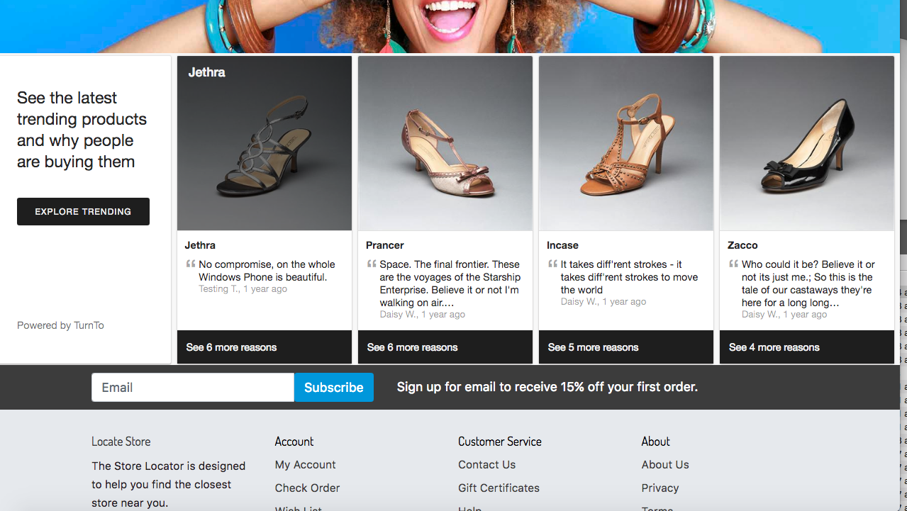

Documentation -> <https://turnto.zendesk.com/hc/en-us/articles/360023587572-Comments-Pinboard-Teaser-5-0>

#### Visual Content Pinboard

The VC Pinboard relies on the following div element to be placed on the page for the widget JS to properly render the data:

<div id="tt-vc-pinboard-widget"></div>

Widget Refresh Function

To use the Visual Content Pinbpard widget on a page that switches product SKUs dynamically, use the built-in set function. It can be called with any SKU in the following manner:

TurnToCmd(‘vcPinboard.set’, {skus: [sku1’,’sku2’], brands: [‘brand1’,’brand2’], tags: [‘tag1’,’tag2’]})

After calling this function, the widget is updated with contents that apply to the provided SKUs.

To customize the visual content pinboard, add your configurations in the vcPinboard property within the turnToConfig object. Here is an example:

<script type="text/javascript">  
 var turnToConfig = {  
 ...  
 vcPinboard: {   
 skus: ['sku1','sku2','sku3'],  
 tags: ['tag1','tag2','tag3'],  
 brands: ['brand1','brand2','brand3'],  
 onFinish: function(){}  
 }  
 ...  
 };  
</script>

Documentation -> <https://turnto.zendesk.com/hc/en-us/articles/360030227731-Visual-Content-Pinboard>

### Other Features

#### JavaScript Order Feed

During the integration process clients typically provide TurnTo with a one-time historical order feed that populates the TurnTo system with past order data. Once TurnTo is live, the JavaScript Order feed passes newly placed orders from the order confirmation page into the TurnTo system.

We recommend adding this JavaScript code on your production site prior to going live so you can start to build your product owner pools early on.

The order feed code has already been placed in the cartridge. See the following template *confirmationinclude.isml*

Order Data Fields

|  |  |  |
| --- | --- | --- |
| Name | Required? | Description |
| orderId | Y | The id of the order |
| email | Y | Customer email address |
| firstName | Y | Customer first name |
| lastName | Y | Customer last name  *Note: If 'firstName' and 'lastName' are not*  *present the JS Feed, we take the first letter*  *of the email as first name and the second*  *letter as last name.* |
| nickName | N | The nickname of the customer |
| postalCode | N | Postal code |
| deliveryDate | N | The date by which the purchased item will be delivered to the customer. Value should be a string in 'yyyy-MM-dd' format (e.g. '2019-02-23' for February 23, 2019). |
| emailOptOut | N | Default value ‘false’. Set to the boolean value 'true' if shopper should receive no emails from TurnTo. |
| items | Y | An array containing data about each line item in the order (see ‘Line Item Fields’ below for a list of objects in the items array) |

Line Item Fields

|  |  |  |
| --- | --- | --- |
| Name | Required? | Description |
| SKU | Y | The SKU of the product |
| title | N | The product name. We strongly recommend that you include this field to avoid errors if the purchased SKU isn't present in your catalog feed. The value passed will never overwrite the catalog feed data for the given SKU. |
| url | N | The product URL on your site. We strongly recommend that clients include this field to avoid errors if the purchased SKU isn't present in your catalog feed. The value passed will never overwrite catalog feed data for the given SKU. |
| itemImageUrl | N | The image URL for the product. We strongly recommend that clients include this field to avoid errors if the purchased SKU isn't present in your catalog feed. The value passed will never overwrite catalog feed data for the given SKU. |
| price | N | The price of the product. The value passed will never overwrite catalog feed data for the given SKU (only used if the purchased SKU wasn't included in your catalog feed). |
| lineItemId | N | The line item id of the order |
| siteKey | Only required for multi-store clients | The TurnTo Site Key of the store where the item was added to the cart |

#### Checkout Comment Capture Widget

**NOTE: To install the Comment Capture widget you must also install the JavaScript Order feed on your order confirmation page, which is added to the cartridge out of the box, see *confirmationinclude.isml***

<div id=”tt-comment-capture”></div>

Documentation -> <https://turnto.zendesk.com/hc/en-us/articles/360022365432-Comment-Capture-5-0>

## Testing Use Cases

**IMPORTANT NOTE: Please contact your TurnTo Customer Success Manager if you have any questions about enabling these features.**

### TurnTo Site Down Scenario

If the Turnto site is down, the JS will not load on the storefront so all of the widgets will not show on the corresponding pages they are configured on. The DOM elements will still be in the page source, but the widgets require the TurnTo JS file loaded via a dynamic URL reference to TurnTo’s site.

i.e. http://widgets.turnto.com/v5/widgets/[site_key]/js/turnto.js

There will be no visable error messages on the storefront, the only error will be a 404 error on the developer console due to the TurnTo JS file not being able to be loaded.

### 

### Q&A Testing

1. Navigate to any product page and find the Q&A module.
2. Enter a search term into the Instant Answers widget and see matching data delivered dynamically from TurnTo
3. Submit a new question

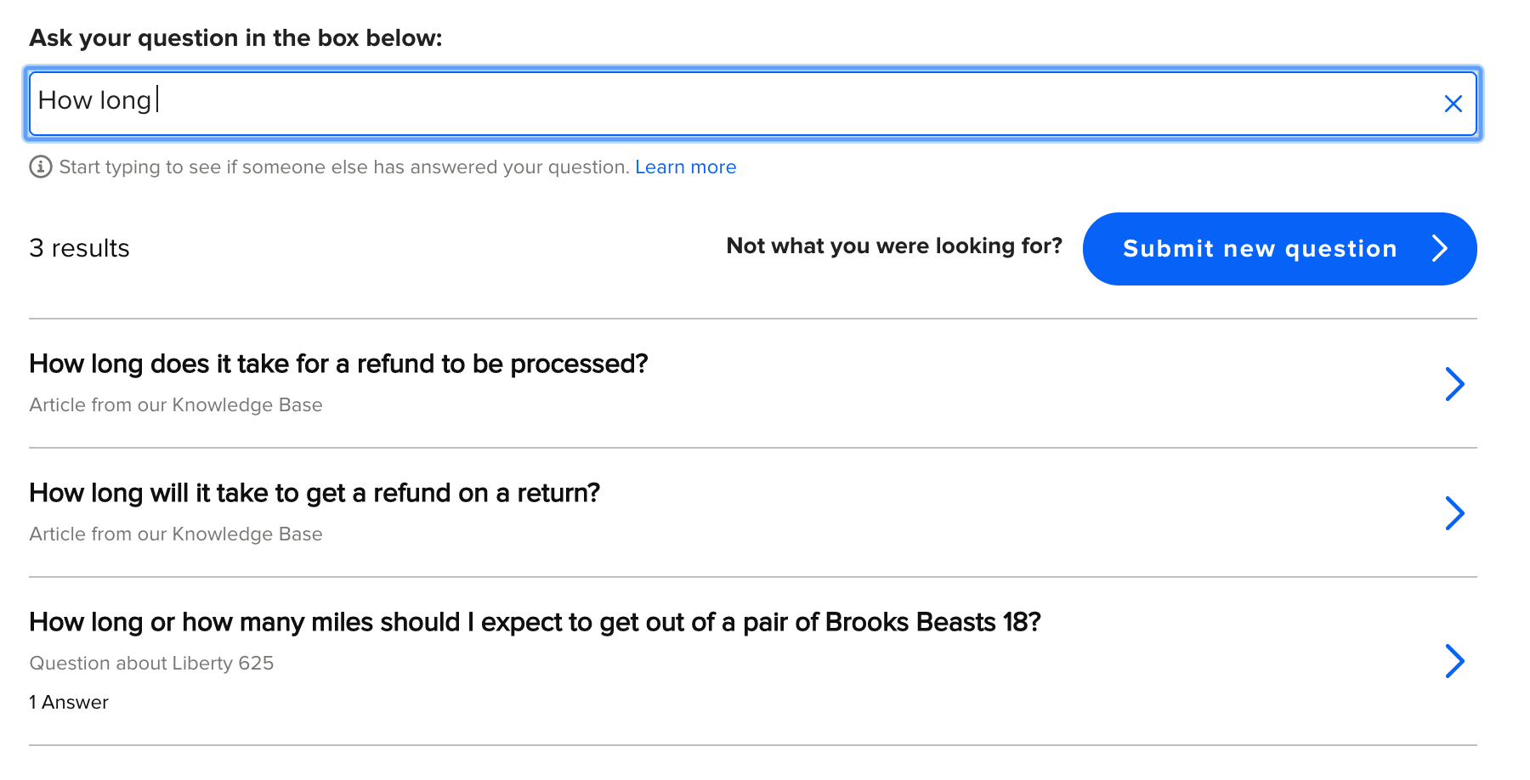

### Reviews Testing

**IMPORTANT NOTE: The Review List widget will only display when there are reviews on the product SKU.**

1. Navigate to the PDP and observe the teaser and review widget:

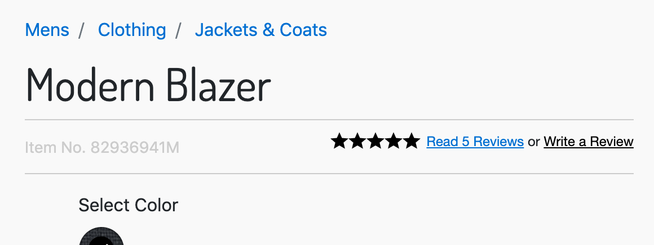

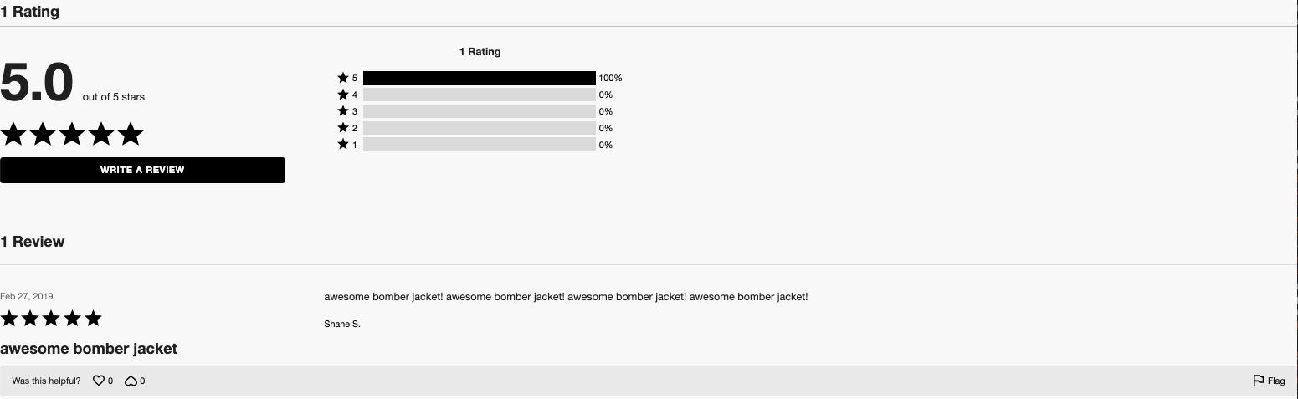

1. Click on the ‘Write a Review’ button and populate some data:

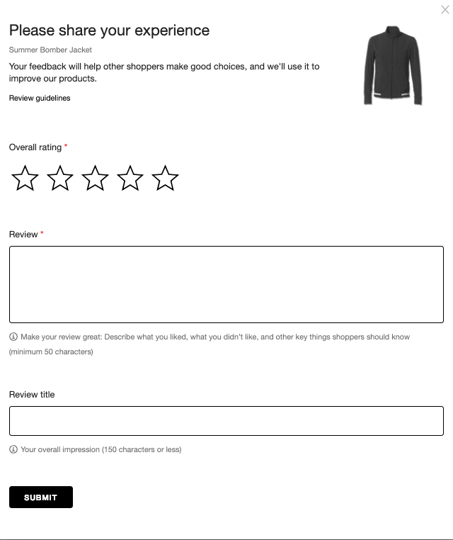

1. After the review has been moderated in the TurnTo dashboard, the review will appear on the PDP:



### Refinements Testing

1. Follow the guide steps in “Configure Average Star Ratings as a Search Refinement” to enable the TurnTo average rating for desired storefront catalog refinements. After setup you will see the following on search and category results page if one or more product(s) have at least one review.

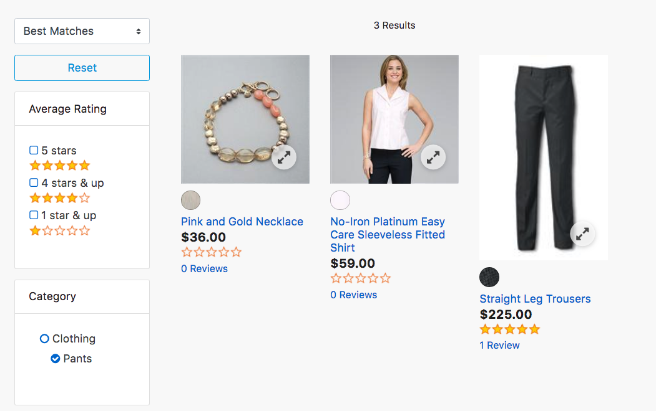

### Checkout Comments

1. Place an order on the storefront and observe the checkout comments module:

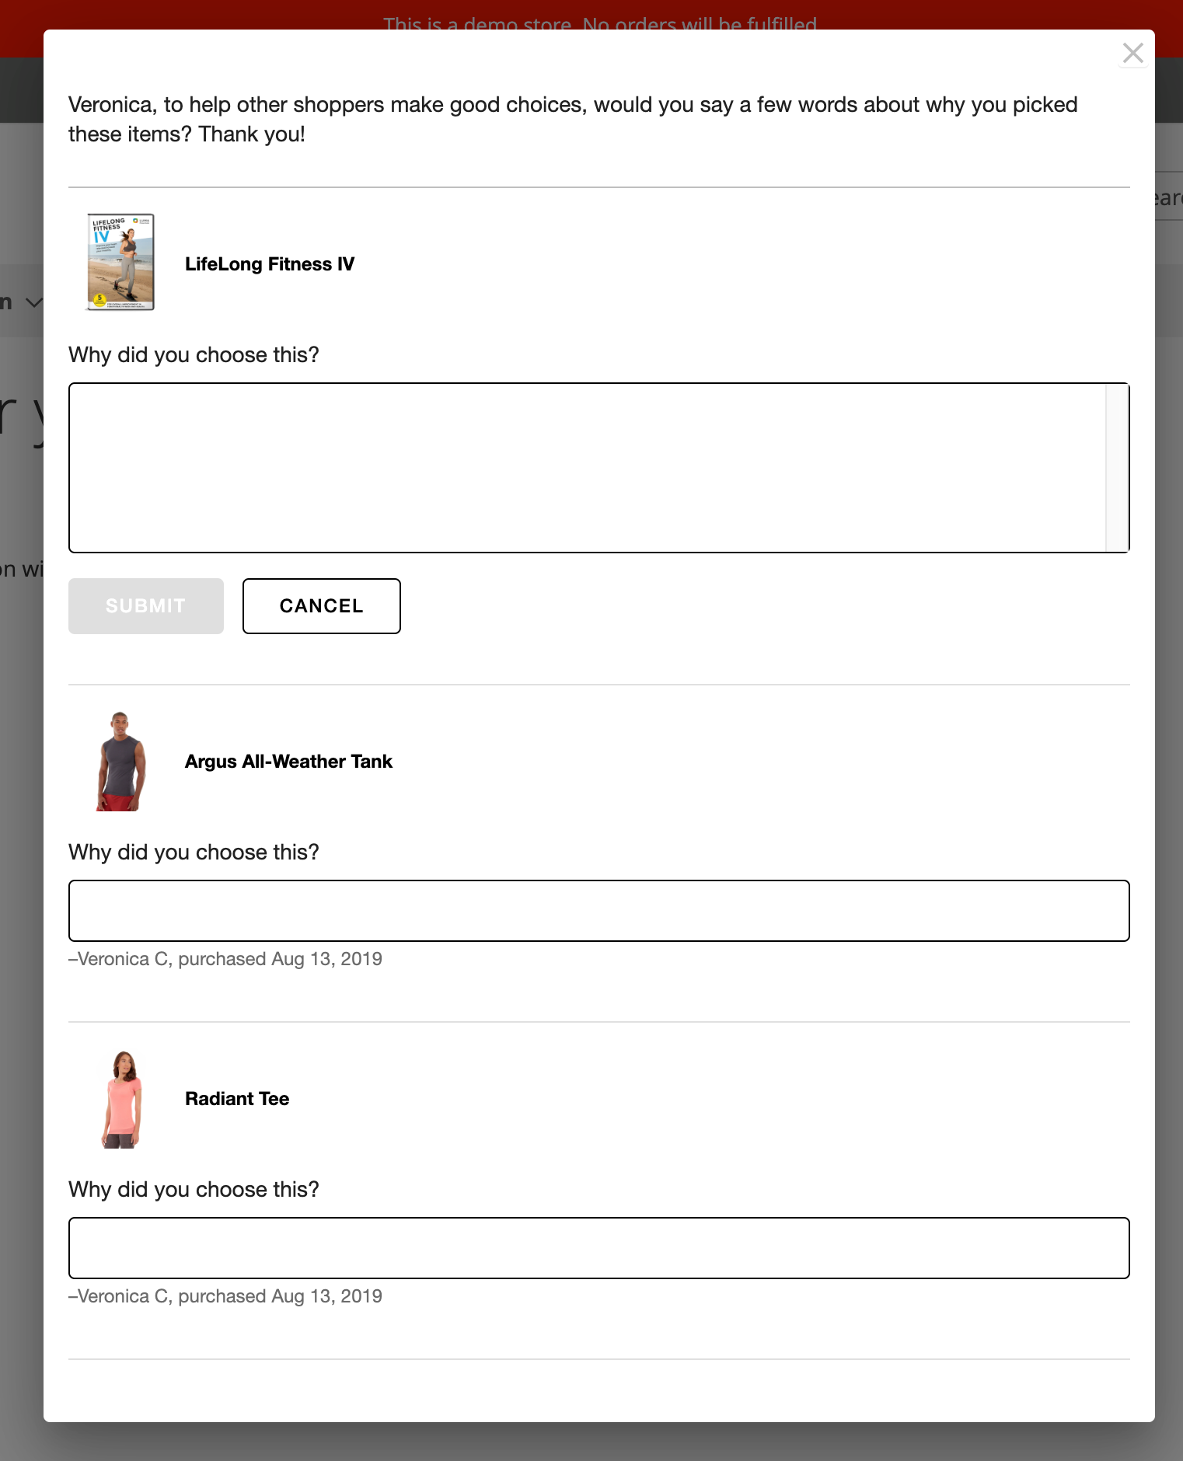

To test any other checkout comment features (category page, etc.) see the installation guide above for the necessary criteria.

### JavaScript Order Feed Testing

1. Create a mock order on your order confirmation page
2. Visit the page with Chrome Web Developer Tools (or Firebug from Firefox) open to the ‘Console’ tab
3. Note any turnto.js errors that you may find. Specifically those that start with “TurnTo: (error) order feed – ”
4. Search for ttreqid call (example 'en_US?ttreqid=1234...') and click on the 2nd one. The Request Method should be POST, not OPTIONS.
5. Scroll to the bottom of the 'Headers' pane in the 'Request Payload' section to see and confirm that the correct order data is being passed.
6. If there are errors in the JavaScript Order Feed or you need further assistance with troubleshooting please contact your TurnTo account team at support@turnto.com .